EXPLORING PERU # 25
16 Days / 15 Nights

Lima, Nazca, Ica, Paracas, Amazon Adventure at Posada Amazonas, Cusco,
Maras Salt Pools and Authentic Quechua Village, Pisac Indian Market and Ollantaytambo Fortress, Machu Picchu

Day-by-Day Itinerary

Day 1 – Friday - Lima - Arrival  Arrival in Lima, the "City of Kings" famous for its Spanish Colonial architecture, extraordinary museums and cuisine. Lima is internationally recognized as the "Gastronomic Capital of the Americas", and its cuisine is considered among the most diverse and exquisite in the world on par with French cuisine. Upon arrival a host will meet and assist you in transferring to the hotel and in registering. | 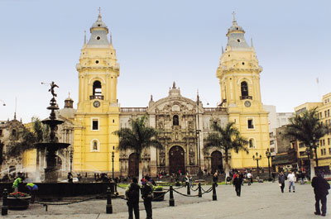

Day 2 – Saturday - Lima City Tour and Larco Museum (B)  Tour of Modern and Colonial Lima including the world famous Larco Museum - This half-day tour visits both the colonial and modern sections of Lima. Colonial sites include the lovely Plaza Mayor, the Government Palace, San Francisco Church and the exquisite Torre Tagle Palace modern day seat of the Ministry of Foreign Affairs. In modern Lima, drive along the exclusive residential areas of Miraflores and San Isidro. | 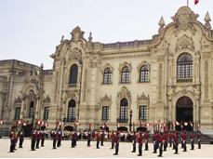

Continue to the Larco Museum, founded in 1926, it displays remarkable chronological galleries providing an excellent overview on 3000 years of development of Peruvian pre-Columbian history. Located in a unique vice-royal mansion of the 18th century built over a 7th century pre-Columbian pyramid is surrounded by beautiful gardens. The Larco Museum also features the finest gold and silver collection from Ancient Peru and the famous erotic archaeological collection, one of the most visited Peruvian tourist attractions. | 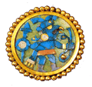

Day 3 - Sunday – Lima to Nazca (B)  Transfer to Nazca by regular bus with VIP service and sofa-bed seats.  6 ½ hours. Travel south along the Peruvian coast to the town of Nazca. The desert and the sea come together in spectacular fashion.  Upon arrival a host will meet and assist you in transferring to the hotel and help you in registering. |  | 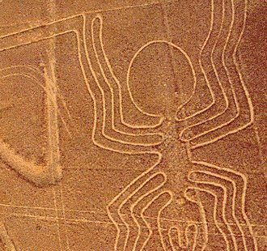
Day 4 – Monday - Nazca Lines over flight (B)  Transfer to the local airport for a spectacular flight over vast drawings, figures like a spider, a hummingbird, a monkey, etc. The Nazca Lines, discovered in 1927, are the most extraordinary legacy left by a culture that flourished in 300 BC. The lines are a series of complex designs, some up to 300 meters long, which can only be seen in their true dimension from an altitude of at least 1,500 feet. The Nazca culture is not believed to have been capable of manned flight. But the question remains as to how they crafted the drawings, what technology they used and what purpose the lines served. | 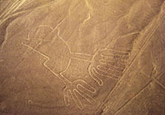

Cantayoc Aqueducts and Antonini Didactic Museum  Visit to the Cantayoc aqueducts, close to town, a complex system of underground aqueducts that allowed the Nazca culture to take advantage of underground water provides evidence of this culture´s technological development in the exploitation of the land.  Continue to the Antonini Museum, which displays a collection of archaeological pieces of the different stages of the Nazca culture. These discoveries are the result of the excavations done in “Cahuachi”. | 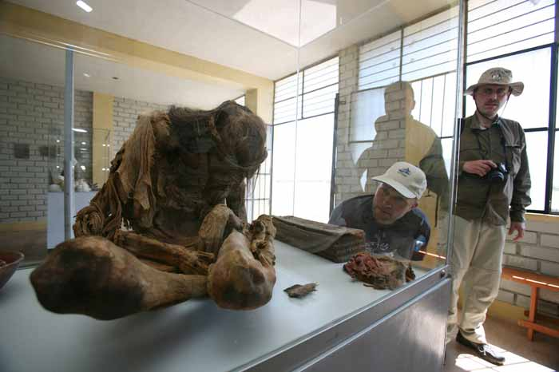
Day 5 – Tuesday - Pampa Galeras - Nazca – Paracas (B, L)  Visit to The National Reserve of Pampa Galeras was established in 1967. This reserve is made up of 6500 hectares which are owned by the peasant community Lucanas located in the department of Ayacucho, province and district of Lucanas. The vicuna (Vicugna vicugna) is the most representative animal in Pampa Galeras and the purpose of this reserve is to protect these animals. We can also find the guanaco (Lama guanicoe), which live free in the pampas. The most impressive bird is the Andean condor (Vultor gryphus); we can see the pissaca (Nothoprocta ornata) and the kiula (Tinamotis penhaldii) as well. With regard to the birds, we can also find the pato jerga (Anas georgica) and the pato sutro (Anas flavirosatris). Transfer to Ica-Paracas area for overnight. |  | 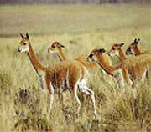

Day 6 – Wednesday - Ballestas Islands - Lima (B)  Early morning yacht ride to the Ballestas Islands. These islands, also known as the Guano Islands, constitute the habitat to millions of birds and sea lions colonies in their natural environment. Pass by El Candelabro (The Candelabra) is a geoglyph of more than 394 feet long, better appreciated from the ocean. Afternoon return to Lima. | 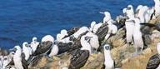

Day 7 – Thursday – Flight to Puerto Maldonado, Posada Amazonas 2 Night Adventure, all meals and excursions included. (B,L,D)  Transfer to the airport for your flight to Puerto Maldonado. Upon arrival in Puerto Maldonado we will welcome you at the airport and drive you ten minutes to lodge town office. While enjoying your first taste of the forest in our gardens we will ask you to pack only the necessary gear for your next few days, and leave the rest at our safe deposit.  This helps us keep the boats and cargo light. Transfer to river pier for a forty five minute boat ride from the Tambopata Port to Posada Amazonas which will take us into the Community’s Primary Forest Private Reserve. | 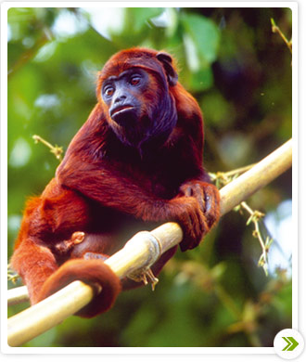

A twenty-minute walk from Posada Amazonas leads to the 30-meter scaffolding canopy tower. A banister staircase running through the middle provides safe access to the platforms above. From atop you obtain spectacular views of the vast expanses of standing forest cut by the Tambopata River winding through the middle. Now and then toucans, parrots or macaws are seen flying against the horizon, or mixed species canopy flocks land in the treetop next to you.  Evening presentation on the Inferno eco-tourism project is available every night from a staff member. | 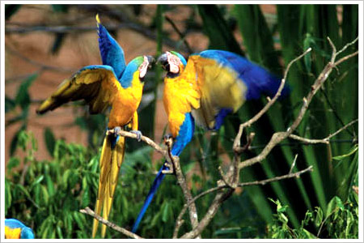

Day 8 – Friday – At Posada Amazonas (B,L,D)  Tres Chimbadas Oxbow Lake: Tres Chimbadas is thirty minutes by boat and forty five minutes hiking from Posada Amazonas. Once there you will paddle around the lake in a catamaran, searching for the resident family of nine giant river otters (seen by 60% of our lake visitors) and other lakeside wildlife such as caiman, hoatzin and horned screamers.  Parrot clay lick: This clay lick is only a twenty minute walk from Posada Amazonas. From a blind located about twenty meters away you will see dozens of parrots and parakeets descend on most clear mornings to ingest the clay on a river bank. Species such as Mealy and Yellow- headed Amazon, Blue-headed Parrot and Dusky headed Parakeet descend at this clay lick. The clay lick is most active at dawn and during the late mornings and mid-afternoons. | 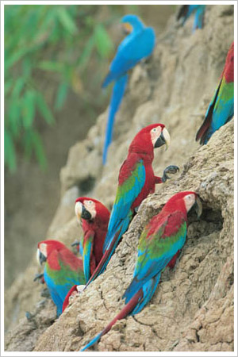

Ethno botanical Tour: A twenty minute boat drive downriver leads you to a trail designed by the staff of the Centro Ñape. The Centro Ñape is a communal organization that produces medicines out of forest plants and administers them to patients who choose their little clinic. They have produced a trail which explains the different medicinal (and other) uses of selected plants. Night walk. You will have the option of hiking out at night, when most of the mammals are active but rarely seen. Much easier to find are frogs with shapes and sounds as bizarre as their natural histories. | 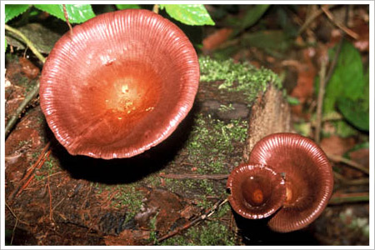

Day 9 – Saturday – Puerto Maldonado – Cusco (B)  Retrace your river and road journey back to Puerto Maldonado and on to the airport for your departure flight to Cusco, at an elevation of 11,440 feet. Upon arrival a host will meet and assist you in transferring to the hotel and in registering.  The rest of the day is at leisure to relax and acclimatize to altitude. | 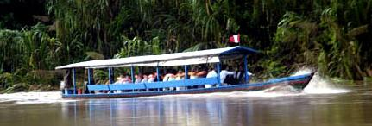

Day 10 – Sunday - Cusco City Tour and Nearby Ruins (B)  Tour of Cusco and Nearby Ruins – Visitors are caught up in the excitement of touring the ancient capital of the Inca Empire, a delightful combination of Inca and colonial architecture. The tour visits important landmarks such us Cusco's Cathedral, Plaza de Armas and Koricancha “The Temple of the Sun”. This tour of the oldest continuously inhabited city in the western hemisphere also includes the nearby ruins of Kenko, Puca-Pucara, Tambomachay as well as the Sacsayhuaman fortress, an imposing example of Inca military architecture. | 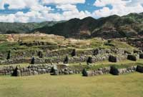

Day 11 – Monday - Cusco – Moray, Maras and Quechuas (B,L)  Moray, Maras Salt Pools and Authentic Quechua Village – Pass through unspoiled and picturesque Andean communities on your way to the Incan agricultural experimental center of Moray, famous for its sunken amphitheater, made up of four circular terraces, which appear to fade away into the earth like an artificial crater. The site was apparently an Inca agricultural research station filled with fertile earth and watered by complex irrigation systems, designed for experimenting with crops at various altitudes (some of which run down to depths of 100 meters). | 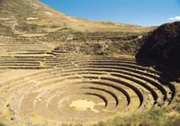

Continue to the impressive Maras salt pools formed by water emerging from a lake inside a mountain in the Urubamba Valley. An amazing view of evaporating ponds for the extraction of salt. Learn about ancestral techniques, which are still used, in agricultural, irrigation and salt-recollection tasks, as well as in Andean festivals and rites.  After lunch, visit an authentic Quechua Village to feel the way of life of the Inca's ancestors. The Inca himself was a noble Quechua. They live off the land and are always wearing their colorful ponchos, see Quechua children scamper about while woman are weaving their family's clothes. A meaningful experience! Lunch is included. | 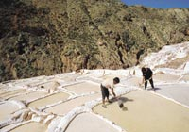

Day 12 – Tuesday - Pisac Market and Ollantaytambo Archaeological Complex (B,L) Full Day Excursion to the Pisac Indian Market and the Ollantaytambo Fortress - Morning departure for a drive through the fertile countryside of the Urubamba Valley to the colonial village of Pisac where an Indian Market takes place Tuesdays, Thursdays and Sundays. Other days you will tour the religious nucleus and archaeological site of Pisac. During your visit to the bustling marketplace you will have the opportunity to bargain with the natives for many different types of Peruvian handicrafts and jewelry. | 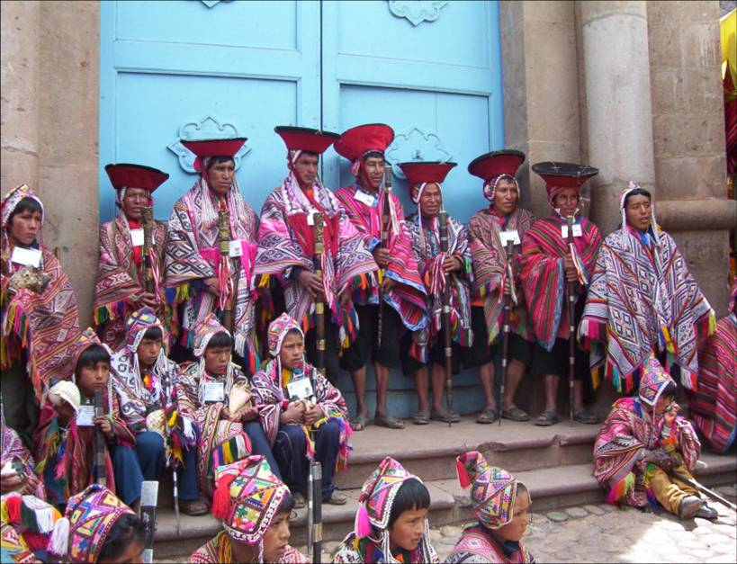

Continue to the Ollantaytambo archaeological complex, the Incas built it as a fort that included a temple, agricultural terraces, and an urban area. There are two distinct sectors: The religious and worship zone, and the residential area. Ollantaytambo was an important administrative center with probable military functions if one considers the walls and towers. There are also traces of ancient roads and aqueducts. The town of Ollantaytambo is called a "Living Inca Town" since the inhabitants maintain very old practices and customs. Lunch is at a beautiful country estate on the shores of the Urubamba River. | 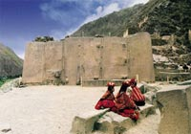

Day 13 – Wednesday - Machu Picchu with overnight stay (B,L)  Morning train ride through the sacred valley of Urubamba to the "Lost City of the Incas," Machu Picchu. Perched 8,200 feet above the valley, it was hidden by mountains and semi-tropical jungles for 400 years until discovered by Hiram Bingham of Yale University in 1911. Archaeologists believe that the Inca "Virgins of the Sun" took refuge from the Spanish Conquistadors here. Guided tour of the ruins upon arrival. Lunch is at the Orient Express’ Sanctuary Lodge located just a few steps from the Inca citadel. | 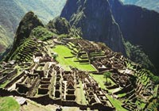

Day 14 – Thursday - Machu Picchu Free Day. Return train ride (B)  Free morning to enjoy one of the most incredible sights on earth, the sanctuary of Machu Picchu. Take as much time as you need to study these magnificent ruins, hike the steep stone-paved trail of Huayna Picchu, the pyramid-shape mountain above Machu Picchu for a breathtaking view of the site, or stroll to the Inca Bridge a secret entrance used by the Inca's army or walk toward the Inca Trail to find the historic Intipunku or Sun Gate. Afternoon return train ride. | 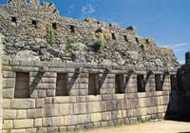

Day 15 – Friday - Cusco – Free Day (B)  Wandering through this lovely city, exploring the astonishing narrow streets of this tile roof colonial town will be your unforgettable experience. You will find something astounding at every turn. Great buys are the traditional Peruvian handicrafts, alpaca-wool sweaters and rugs, ponchos, pottery, gold and silver jewelry, leather goods, etc. Because there are such a variety of products, we strongly suggest that when you like any particular item, you should buy it - you may not find the same item in other store. Many visitors to Cusco return home wishing they had a free day to discover this imperial city on their own, a free day in Cusco is a MUST! | 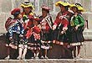

Day 16 – Saturday – Cusco – Lima – Home (B)  Transfer to the airport for your departure to Lima and your connecting international flight. Arrive home full of great memories of the rich tradition of Colonial Lima and the mystical Land of the Incas. | 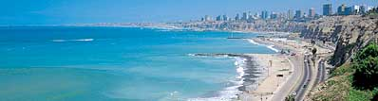

   End of Services   

Tour includes:
● All airport transfers listed in the itinerary
● Baggage handling at airports and at hotels
● All tours and excursions indicated in the itinerary
● All entrance fees and transfers needed to operate tours and excursions
● All train tickets, bus tickets and boat services needed to operate tours and excursions
● Excursion to Machu Picchu is aboard the Vistadome Train.
● Lunch in the excursion to Machu Picchu: Lunch at Sanctuary Lodge
● Service of a bilingual licensed tour guide for all tours and excursions
● All meals indicated in the itinerary. B for breakfast, L for lunch. D for dinner
● Hotel accommodation and hotel service charge
● Hotel taxes are exempt for foreigners visiting Peru
● When domestic airfare within Peru is specified as included: Airfare includes all queues, security fee, fuel surcharges and 18% Peruvian sales tax.

Not included:
● Extra expenses in case of modifying the itinerary due to flight cancelation, strikes or blocking of roads and train tracks by demonstrators or political activists. Travel insurance is strongly recommended.
● When staying overnight in Machu Picchu, the entrance fee for the 2nd day in Machu Picchu is not included. This can be added to the itinerary upon request
● Expenses such us beverages on meals, tips, laundry, phone calls and other personal expenses are not included
● When a cruise to the Galapagos Islands is part of the itinerary, the Galapagos National Park Tax is not included. It is payable upon arrival at the Galapagos Islands
● Airport departure taxes are not included: Approximate cost is US $31.00 for international flight, and US $7.40 for each domestic flight

Cancelation Penalties for FIT’s
● The cancellation penalty is 100% when services are cancelled within 30 days of arrival.
● When the deadline to cancel without penalties is longer than 30 days, Fiesta Tours Peru will notify you upon confirmation of services.
● Amazon river cruises and Galapagos island cruises are not refundable when services are cancelled within 90 days of arrival. When deadline changes, clients will be notified.

General Conditions for Groups
● Rooming list is due 50 days prior to arrival ⁽¹⁾.
● Payment is due 50 days prior to arrival.
● An updated number of rooms to be needed is recommended 90 days prior to arrival.
● Hotels’ cancellation penalty will be provided upon confirmation.
● Transfers and tours have a 100% cancellation penalty for services cancelled within 30 days of arrival.
● Airfares have a 100% cancellation penalty for flights cancelled within 35 days of departure.
● Inka Terra Hotels requires a 20% non-refundable deposit 95 days prior to arrival. They reserve the right to request a 20% non-refundable deposit at any given moment. Final rooming list is due 65 days prior to arrival.
⁽¹⁾ The following hotels will require the final rooming list 65 days prior to arrival: Belmond Hotels, J.W. Marriott and Gran Hotel Faraona. ^{V-Apr-15-2014}

Please review our General Conditions
http://www.fiestatoursperu.com/gcenglish/

    

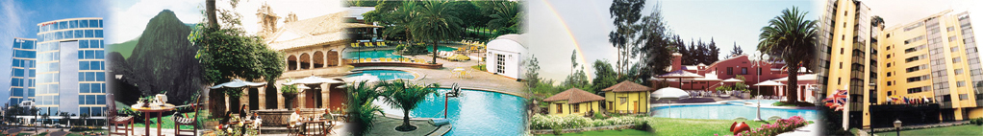
Hotels used in Tour Packages: For Exploring Peru Series – 2015
City | Tourist | Tourist Superior | First Class | First Class Superior | Deluxe | Luxury
Lima | Tambo # 1 or Los Girasoles | Casa Andina Classic Miraflores Centro or Tambo # 2 | Casa Andina Select Miraflores or  Jose Antonio | Melia Lima o Dazzler or Four Points by Sheraton | Casa Andina Private Collection Miraflores or El Pardo | Westin Lima Hotel & Convention Center or Country Club Lima
Cusco | Samay or San Agustin Internacional | Eco Inn or San Agustin El Dorado or Terra Andina Hotel (STD) or Casa Andina Classic Cusco | Terra Andina Hotel (Sup) or Sonesta Hotel Cusco or  Jose Antonio | Casa Andina Private Collection Cusco or Novotel | Palacio del Inka A Luxury Collection Hotel | Belmond Monasterio
Valle Sagrado | Inkallpa Valle Sagrado or Agustos Urubamba | Villa Urubamba or San Agustin Monasterio de la Recoleta | Sonesta Posadas del Inca Yucay | Casa Andina Private Collection Valle Sagrado | Sol y Luna (casita sup) or Aranwa Sacred Valley Hotel & Wellness | Tambo del Inka A Luxury Collection or Belmond Rio Sagrado
Aguas  Calientes | Hatun Samay Machu Picchu | El Mapi or Casa Andina Classic Machu Picchu | El Mapi or Casa Andina Classic Machu Picchu | Casa del Sol Machu Picchu Boutique Hotel | Inkaterra Machu Picchu Pueblo or Sumaq | Belmond Sanctuary Lodge
Arequipa | Casa Andina Classic Arequipa | Tierra Viva Arequipa Plaza | El Cabildo | Sonesta Posadas del Inca Arequipa | Libertador Arequipa | Libertador Arequipa
Colca | Eco Inn Valle del Colca | Casa Andina Classic Colca | Colca Lodge or Aranwa Pueblito Encantado | Colca Lodge or Aranwa Pueblito Encantado | Colca Lodge or Aranwa Pueblito Encantado | Casitas del Colca
Puno | La Hacienda Plaza de Armas | Eco Inn Puno | Sonesta Posadas del Inca Puno | Sonesta Posadas del Inca Puno | Casa Andina Private Collection Puno | Libertador Lago Titicaca
Trujillo | Posada del Rey | Costa del Sol Trujillo | Costa del Sol Trujillo | Libertador Trujillo | Libertador Trujillo | Casa Andina Private Collection Trujillo
Chiclayo | Los Portales de Chiclayo | Los Portales de Chiclayo | Costa del Sol Chiclayo | Casa Andina Select Chiclayo | Casa Andina Select Chiclayo | Casa Andina Select Chiclayo
Ica | Las Dunas | Las Dunas | Las Dunas | Las Dunas | Las Dunas | Las Dunas
Paracas | San Agustin Paracas | San Agustin Paracas | La Hacienda Bahia Paracas | La Hacienda Bahia Paracas | DoubleTree by Hilton Resort Paracas or Aranwa Paracas Resort & Spa | Hotel Paracas A Luxury Collection Resort
Nazca | Casa Andina Classic Nazca | Majoro | Majoro | Hotel Nuevo Cantayoc | Hotel Nuevo Cantayoc | Hotel Nuevo Cantayoc
Iquitos | Ceiba Tops | Ceiba Tops | Ceiba Tops | Ceiba Tops | Ceiba Tops | Ceiba Tops
Puerto  Maldonado | Posada Amazonas | Posada Amazonas | La Hacienda Concepcion | La Hacienda Concepcion | Inkaterra Reserva Amazonica | Inkaterra Reserva Amazonica

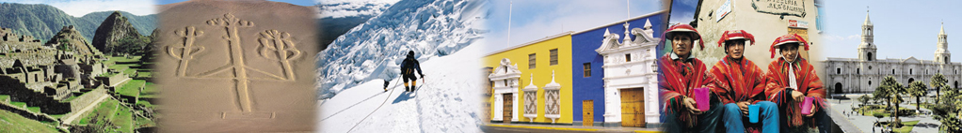
Exploring Peru Series – 2015
Prices per person in US$ - Airfare not included
Exploring Peru  Tour Number | Hotel Category | Dbl | Tpl | Sgl | Single Alone  Surcharge
# 25 | Luxury | $6034 | $6584 | $9207 | $1137
# 25 | Deluxe | $4827 | $4663 | $6775 | $1137
# 25 | First Class Superior | $3836 | $3736 | $4992 | $1057
# 25 | First Class | $3556 | $3512 | $4559 | $1057
# 25 | Tourist Superior | $3510 | $3470 | $4436 | $1157
# 25 | Tourist | $3379 | $3307 | $4043 | $1157

